**Global Vaccine Action Plan**

*Secretariat Annual Report 2016*

*Priority Country report on progress towards*

*GVAP-RVAP goals*

**DEMOCRATIC REPUBLIC OF CONGO**

1. **Progress towards achievement of GVAP goals**
2. **Summary**

This summary table describes the current situation in DRC regarding achieving the GVAP goals. Data used to assess progress towards achievement of GVAP goals are included in the annex (Country immunization profile).

| **Area** | **Indicator** | **DR Congo** |
| --- | --- | --- |
| **5. Reach 90% national coverage and 80% in every district with DTP3cv** | **National coverage (2015 WUENIC)** | **81%** |
| **Drop-out rate DTP1 to DTP3 (2015 WUENIC)** | **1%** |
| **Actual numbers of children that dropped out (2015 WUENIC)** | **29,937** |
| **Difference between poorest and richest quintile in DTP3 coverage (2013 DHS data)** | **34.9** |
| **% of districts reaching 80% coverage (2015 JRF)** | **86%** |

**3.3 Goal 3: Meet vaccination coverage targets**

* 1. **Achieve 90% national coverage and 80% in every district with three doses of diphtheria-tetanus-pertussis containing vaccines**

While DRC has not yet reached the goal of 90% national coverage for three doses of DPT-containing vaccine (pentavalent), according to the WHO-UNICEF estimates, it achieved an overall coverage of 81% in 2015 – up from 74-75% from 2011 to 2013. The WUENIC dropout rate from the first to the third dose of pentavalent vaccine was reportedly 1%. However, the 2013 DHS found a pentavalent coverage rate of only 61% national in 2012 (while the WUENIC rate was 75% for that same year) and a dropout rate of 25%.[1] Administrative data show a marked improvement in district-specific coverage rates in the past five years (see map in the Annex). However, there are no WUENIC estimates for district coverage and given the fact that there is a 13-point difference between administrative and WHO-UNICEF DPT3 coverage estimates for 2015 (94% vs. 81%), the actual degree to which the country has met the goal of 80% coverage in each district is unknown.

Concerning other vaccines in the immunization schedule, the WUENIC national estimates for 2015 were in the upper 70s for measles and three doses of polio vaccine, the mid-70s for PCV3 and BCG, and 65% for yellow fever vaccine. The increase in WUENIC coverage rates for these vaccines in the past five years was less than for pentavalent vaccine; for example, polio coverage was 77% in 2011 and 78% in 2015. The fact that administrative coverage data show national coverage rates of 90% or greater for most vaccines, except measles and PCV3 (at 89% and 86%) highlights issues with the quality of immunization data in DRC.

There are large income and geographic inequities in immunization coverage. The difference in coverage of three pentavalent doses between the lowest and highest income quintile in the 2013 DHS was 35 percentage points (48% vs. 83%), while the coverage rate for all vaccines jumped from 36% in the lowest quintile to 65% in the highest (see figure in the Annex). Those in the middle quintile had rates much closer to the lowest than the highest quintile – indicating great inequality by income. The largest number of non- or under-immunization children are in the country’s nine poorest DPSs.[2]

The performance of DRC’s routine immunization program is affected by serious health system challenges. These include:

* **A lack of investment in human resources for health and consequent high attrition rates and low motivation among health workers.** As mentioned above, most health workers receive no government salary and many do not even receive the inadequate risk bonus. Consequently, they rely on a share of revenues generated by user fees for curative care services. This creates a disincentive for health workers to provide non-remunerative services, such immunization, especially outreach activities and other extra efforts to improve vaccination coverage that require time away from the health center. Many health facilities in the poorest provinces, where user free generation is low, reportedly charge patients for vaccinations, further suppressing coverage.[3]
* **Insufficient availability of immunization services**. According to a Service Availability and Readiness Assessment (SARA) conducted in 2014, the number of health facilities in DRC – both public and private – is sufficient, with more than 600 hospitals, 10,000 health centers (of different levels) and more than 5,500 health posts.[4] This yields a ratio of 2.2 health facilities per 10,000 people, meeting the WHO recommended benchmark of 2/10,000. Seventy-five percent of the facilities in the assessment were found to provide immunization services. However, most (59%) held immunization sessions only once a month, 37% held them once a week, and only 2% had immunization services available on a daily basis. A key reason – in addition to the health worker issues described above – is the fact that only 16% of the 1,012 health facilities in the SARA study had refrigerators, and only 2% of health posts. Thus, health facilities must collect vaccine from the district medical stores themselves on the day of an immunization session. This situation may have improved recently with the purchase of addition cold chain equipment through the GAVI HSS grant.
* **Frequent vaccine shortages and stockouts**. Vaccine stockouts are common at all levels of the health system in DRC. At the central level, there were stockouts of BCG, yellow fever, and PCV vaccines in 2015 and of measles and BCG in 2014. [5] As of early July 2016, there was no supply in the central stores of bivalent OPV and IPV and only one month’s supply of TT vaccine. Some of these stockouts are due to a global supply shortage, notably BCG, which was absent from the central store for 73 days in 2015.[6] Delays in the Government releasing funds for vaccine purchases also contribute to the stockouts at this level.

At the sub-national level, 92% of districts surveyed in the PCV post-introduction evaluation (PIE) in 2014 had experienced a stockout of at least one vaccine in the previous six months, including PCV, even though it was available at the central level during at the time.[7] This points to severe distribution problems from the national to the lower levels. Only two provinces (Bas-Congo and Bandundu) and the city of Kinshasa have vaccines delivered by road; all other provinces are at the mercy of a few air-freight companies for their vaccine deliveries. These companies have routes and itineraries that do not necessarily meet the needs of the provinces, and they charge more than $2 million a year to airship vaccines to the interior. In addition, many health provinces (DPSs) do not have appropriate, functioning means of transporting vaccines to the districts, although more are now obtaining vehicles with HSS support.

The unavailability of vaccines at the health facility level was the top reason found in the 2013 DHS that children did not get vaccinated – cited by 26% of parents whose children did not receive vaccines on schedule.[8] Vaccine stockouts were also found in the 2012 EPI review to be the cause in 27% of the cases where planned outreach activities did not take place.[9] While health facilities without refrigerators are not expected to store vaccine, the SARA study found that vaccine stockouts in facilities with refrigerators were also common. At the time of the assessment team’s visit, 44% of these facilities had no PCV vaccine and 19-24% had stockouts of measles, pentavalent or polio vaccines.[10] These stockouts are due to the vaccine shortages at high levels, as well as to a lack of transport at health facilities to collect vaccine from the district stores.

* **Inadequate outreach activities**. According to the SARA study, 80% of health facilities offering immunization provide services only at the facility. The 2013 DHS found that, while 27% of children lived far enough away from a health facility to be eligible for outreach services, only 7% of vaccinated children were reached through this strategy, increasing the likelihood of their being missed or not completing these immunizations. A lack of transportation was given as the reason outreach activities did not take place in 41% of cases in the 2012 EPI review.[11] Other likely factors are the shortage of health workers and lack of financial incentive to conduct outreach activities.
* **Insufficient community-based communications and community involvement in health and immunization promotion**. DRC has established a system to link health facilities to each community and involve community members in health promotion, including immunization. In principal, one community volunteer (*relais communautaire*) exists for every 25-30 households, and one volunteer per village is a member of the Development Committee (CODESA) for the catchment area (*aire de santé*) of the health center. In the area of immunization, these volunteers inform community members about vaccines and immunization services, help plan and implement disease surveillance and vaccination activities, track immunization defaulters, and participate in health district council meetings. Each DPS has a communications focal point and most districts have community workers (*animateurs communautaires*) who support the health centers and community volunteers with communication and social mobilization activities. The PCV post-introduction evaluation (PIE) found that 34% of mothers knowledgeable about the new vaccine had learned about it from a community volunteer and they were the #2 source of information after health personnel.[12]

However, although the number of community volunteers has reportedly increased, the reality on the ground is different. According to the 2012 EPI review, these volunteers often lack motivation and are increasingly disengaged in some districts.

Inadequate knowledge and demand from the population were found to be a major reason for children not being vaccinated. In the 2012 DHS, coverage for pentavalent vaccine fell from 81% for the first dose to 61% for the third (a dropout rate of 25%), while the dropout rate for polio vaccine from the first to the third dose was 28%. A lack of knowledge about the importance of vaccination, about the need for more than one dose for several vaccines, and about the time and place of vaccination were commonly cited by mothers whose 1-11 month olds did not complete their vaccinations.[13] Religious objections were also a reason for children not being vaccinated, accounting for 7% of responses about all factors contributing to the non-vaccination of children.

The results of these factors – along with inadequate supervision – is many missed opportunities. A child may come to the health center, but it’s not the one day of the month when an immunization session is held, or if it is, certain vaccines are not available, discouraging parents from coming back. Health workers may also miss the opportunity to inform mothers of the needs to bring their child back for subsequent doses and when to do this.

Given the severity of these problems – the lack of salaries for most health workers, the infrequency of immunization services and frequent vaccine stockouts – not to mention the low disbursement rate and delays in the release of government funds for immunization and the presence of armed groups in some areas – it seems quite remarkable that the WHO-UNICEF national coverage estimate for DPT3 is 81%, a figure that surpasses that of several other countries in the region (e.g., Nigeria, Uganda, Chad) and matches that of Indonesia. It may be that the WUENIC estimate is high, given the 14 percentage point difference between the WUENIC and DHS DPT3 coverage estimates for 2012. Other possible explanations for this relatively high coverage include:

* **Implementation of vaccination campaigns and special events** that raise awareness of and/or increase access to immunization. These include periodic intensified routine immunization campaigns (PIRIs) that have taken place in some provinces in recent years, and African Vaccination Weeks. In addition, the numerous polio campaigns that go door-to-door have increased the population’s knowledge about and demand for vaccination in general.
* **Implementation of the Reach Every Zone (REZ) strategy** in 65 of the worse-performing districts (13% of all districts) through the GAVI HSS I grant, supplemented by support from the Gates Foundation, WHO and other partners. Immunization coverage in these districts has increased markedly from 2010 to 2014 (see Section B below). Through the HSS II grant, the number of target districts for REZ support has increased to 112.

**ANNEX: Country immunization profile**

Figure 5: All vaccines national coverage, DRC, 2000-2015

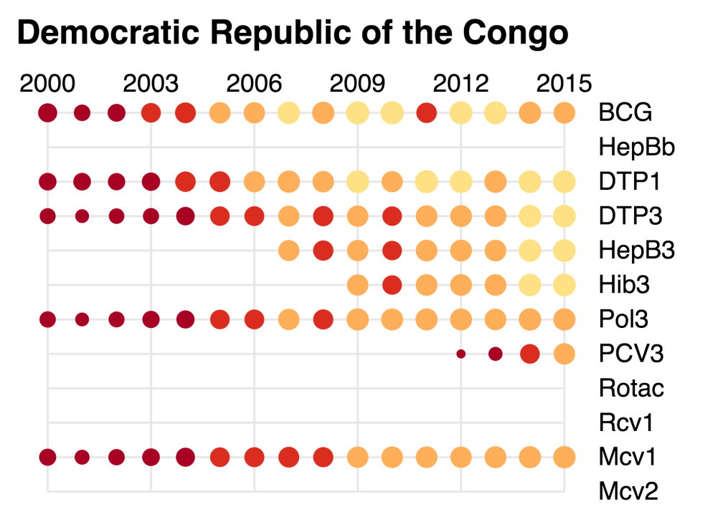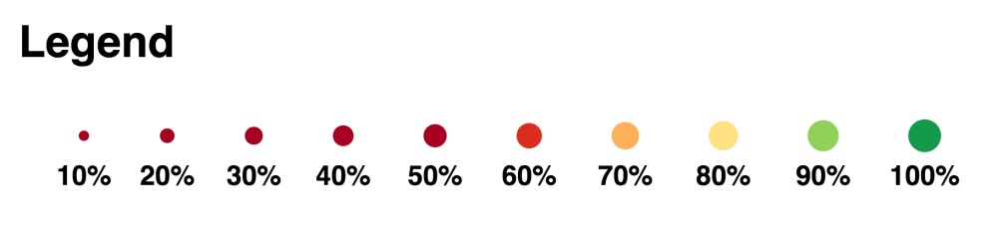

Table 2: Reported DTPcv doses administered & coverage, DR Congo, 2000-2015

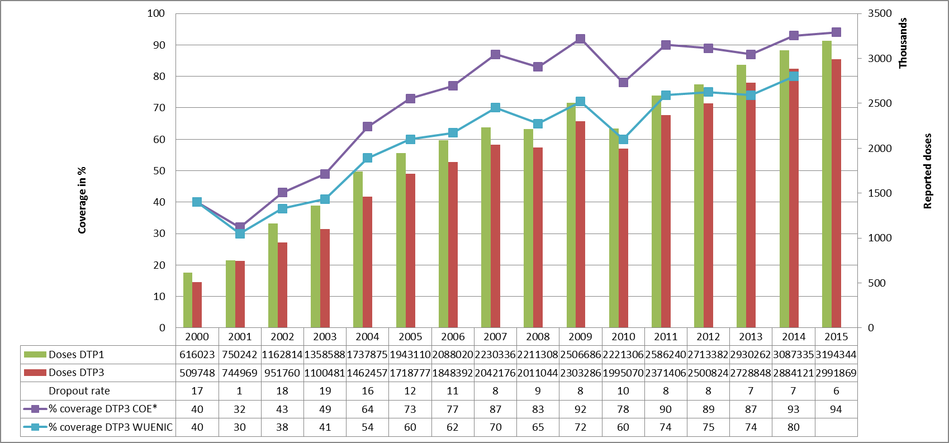

* COE: country Official Estimates

Source:

WHO/IVB database, data reported to WHO by member states as of 1 July 2016

WHO/UNICEF national coverage estimates, 2014 revision, data as of July 2015

Figure 6: Percentage of district achieving <50%; 50-79% and ≥80% coverage, 2000-2015

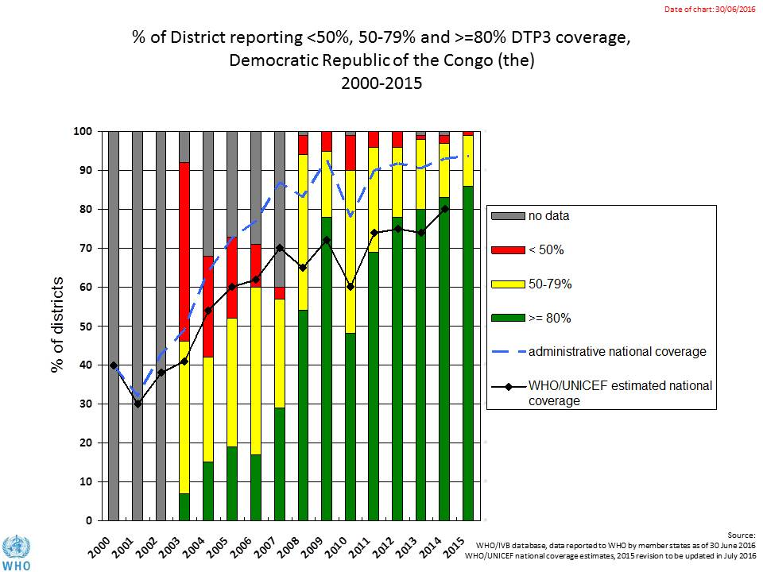

Figure 7: DTP3 coverage by district/province, DRC, 2010 and 2015 (administrative data)

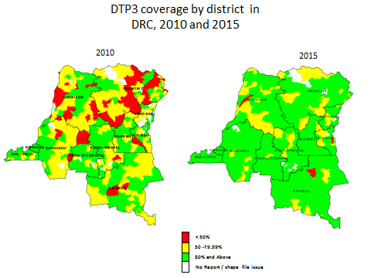

Figure 8: Immunization coverage data disaggregated by sex and wealth quintile

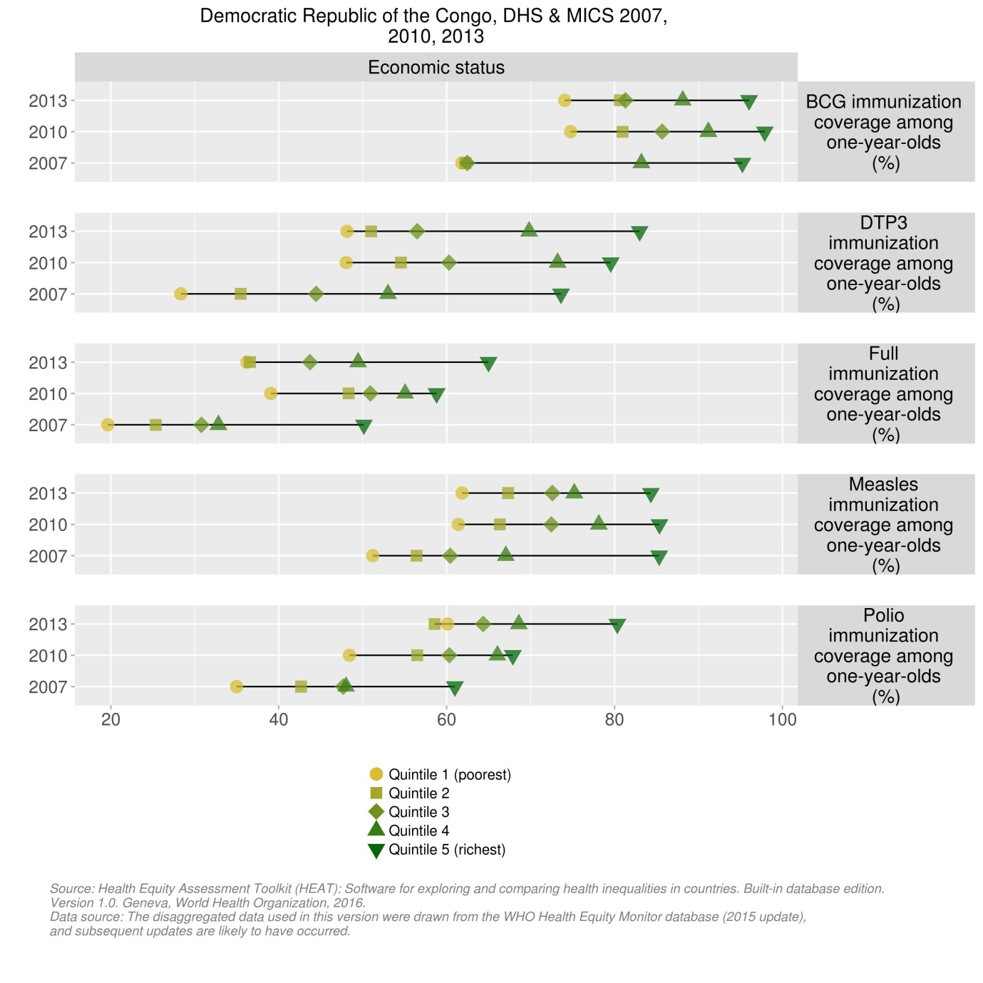

1. cMYP 2015-2019.
2. 2015 joint appraisal report for DRC.
3. 2015 joint appraisal report for DRC.
4. WHO. Service Availability and Readiness Assessment (SARA) in the Democratic Republic of Congo, June 2015.
5. Draft EPI Action Plan for 2016, February 2016.
6. Draft EPI Action Plan for 2016, February 2016.
7. Post-introduction evaluation report for PCV-13 in the Democratic Republic of Congo, 27 March – 11 April 2014.
8. cMYP 2015-2019.
9. HSS II application to GAVI by DRC, 20 April 2014.
10. WHO. Service Availability and Readiness Assessment (SARA) in the Democratic Republic of Congo, June 2015.
11. HSS II application to GAVI by DRC, 20 April 2014.
12. Post-introduction evaluation report for PCV-13 in the Democratic Republic of Congo, 27 March – 11 April 2014.
13. cMYP 2015-2019.